# Experiment # 4

# Verification of Ohm’s Law on breadboard using DMM

**Objectives:**

In this lab we verified ohm’s law through practical experiment

# Apparatus:

1. Power supply
2. Breadboard
3. Wires
4. Digital Multimeter
5. Resistor

# Procedure:

1. First we connect the components and the wires according to the circuit diagram as given below:

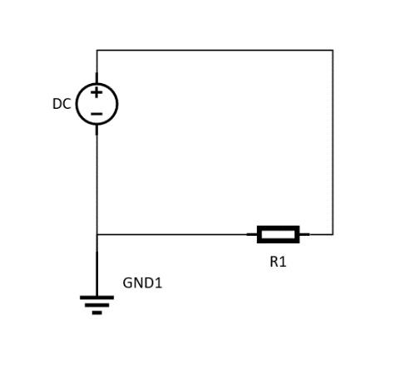

Figure 9 Circuit Diagram

1. We set the power supply at certain voltage and then measure the current through digital multimeter.
2. Repeat the previous step several times and then graph all the values.
3. If the graph is straight line then this verifies the ohm’s law.

# Observation:

**R=1k Ω**

|  |  |  |
| --- | --- | --- |
| **Serial No.** | **Voltage (v)** | **Current (A)** |
| 1. |  |  |
| 2. |  |  |
| 3. |  |  |